**CURE Soft Trial**

All invasively ventilated patients who come into ICU will be screened with inclusion and exclusion criteria as to whether they are eligible to be included in the trial.

An eligible patient is either randomised into **SPV (standard practice ventilation)** or **MBV (model-based ventilation)** put on the CURE Soft programme.

It is important that data from **ALL PATIENTS IN CURESOFT TRIAL**.

**To set up CURE Soft:**

1. Open CURE Soft programme: “**start*Cure***” icon on desktop.
2. Check "***Settings***", choose "***Serial port***" and make sure the Serial port is "***COM3***", Choose either “**MBV”** or **“SPV”** and the appropriate Patient idthen click "***Apply***" (Note MBV,SPV and the group number is given by the screening program)

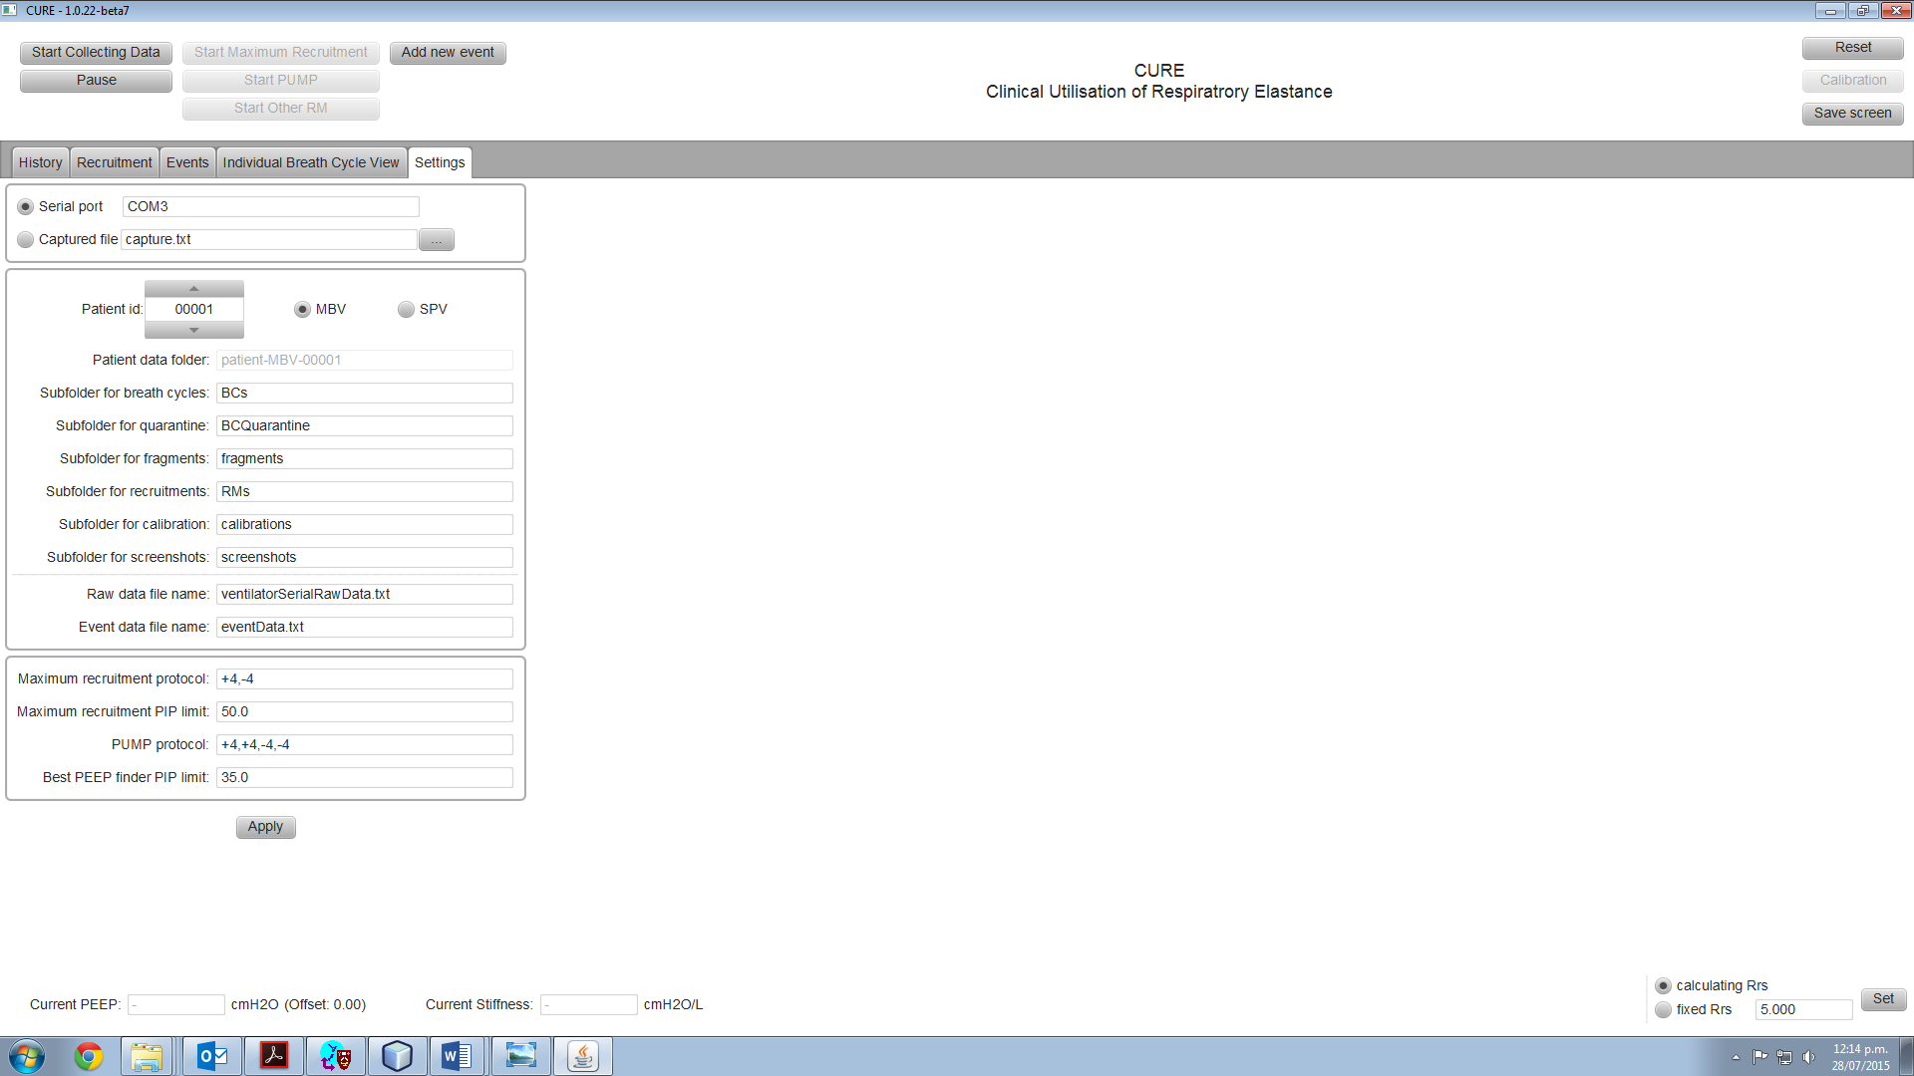

Step 3.

(b) Click Start “Collecting Data” button

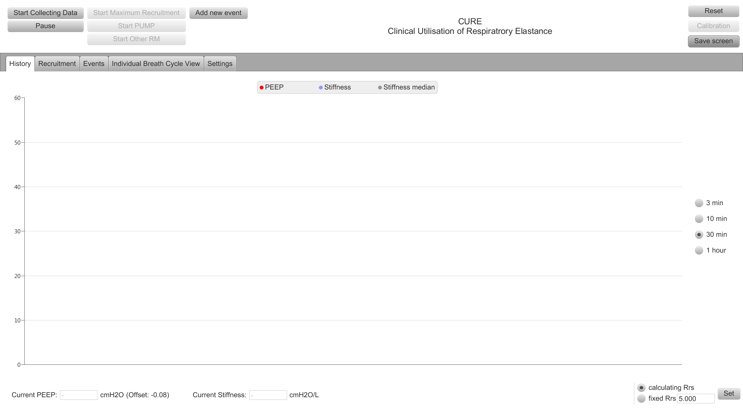

(a) Go to History tab

Step 4. The grey “Start Collecting Data” button will go **red** and you should see a graph of PEEP and lung stiffness

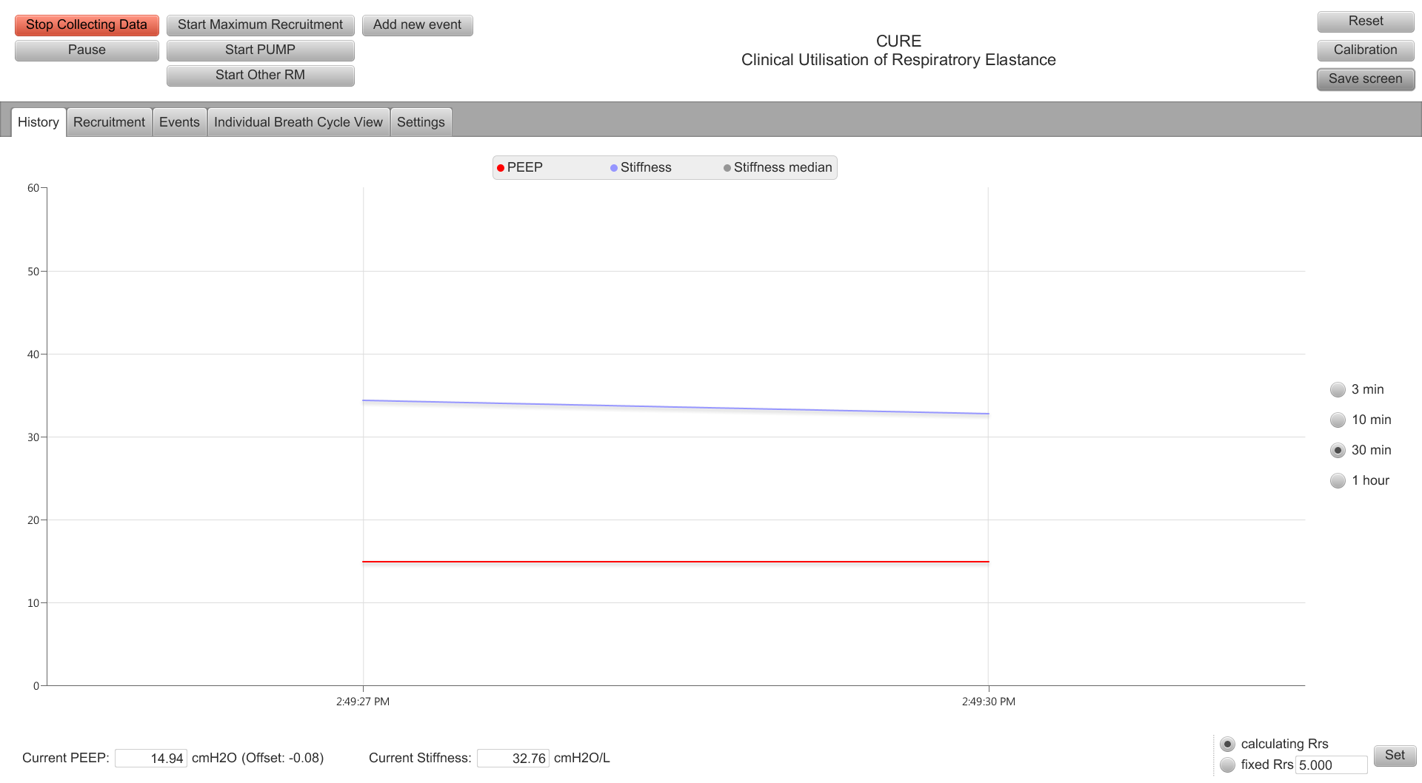

Step 5. Click “***Calibration***” button and enter patient’s PEEP

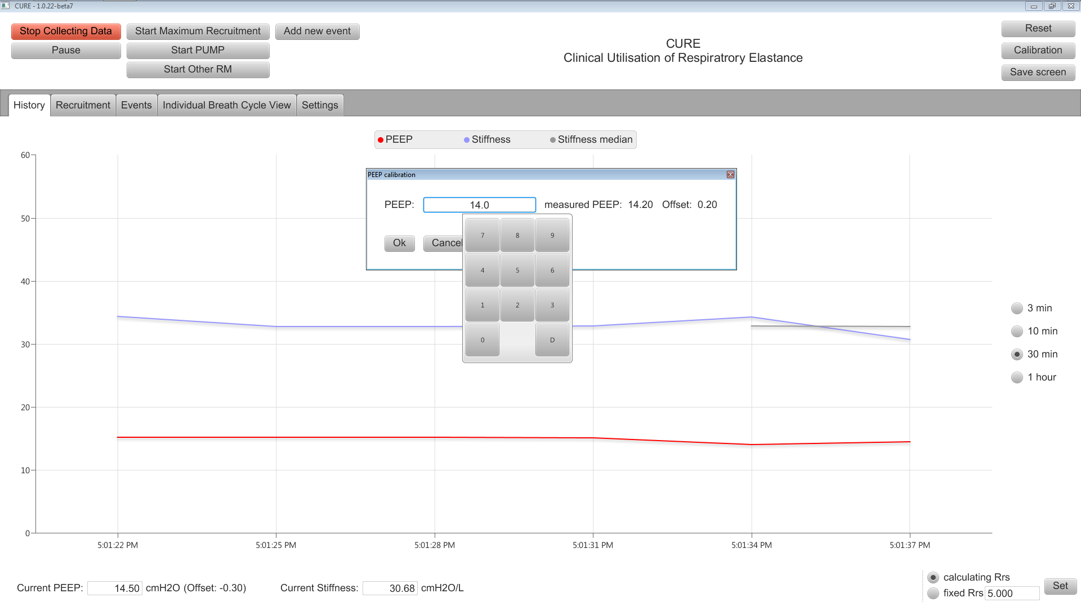

Use the touch number pad to type in the PEEP then click “***OK***”

**Now you have finished initial setup of CURE Soft!**

**FOR patients RANDOMISED to receive the Intervention (Model Based Ventilation)**

**Maximum recruitment manoeuvre (MaxRM) procedure: This is carried out initially and then only repeated if the patient meets specific criteria. *See protocol guidelines.***

Prior to Maximum Recruitment Manoeuvre:

* + Increase the patient airway cuff pressure to 50 cmH2O
  + Administer appropriate muscle relaxant and sedation
  + Set peak airway pressure alarm on ventilator to 55 cmH2O

Step 1: Click “***Start recruitment manoeuvre***”. The message box shown below will show up.

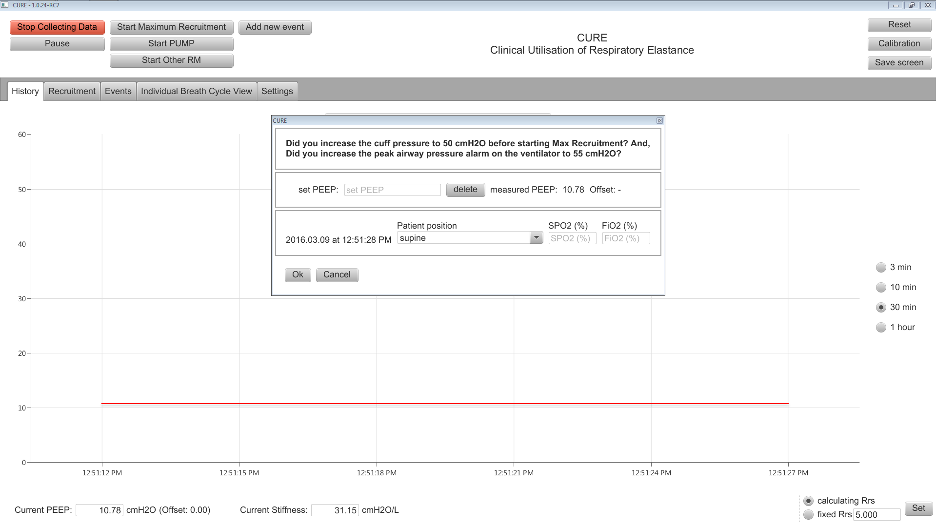

Enter in patient position, SpO2 and FiO2 in the appropriate fields

e.g. position = ***“supine”*** *SpO2* = **“90%”** and *FiO2* = “**50%”**

Step 2: Enter the set PEEP value shown on the ventilator and correct SPO2 and FiO2 hen click “Ok”

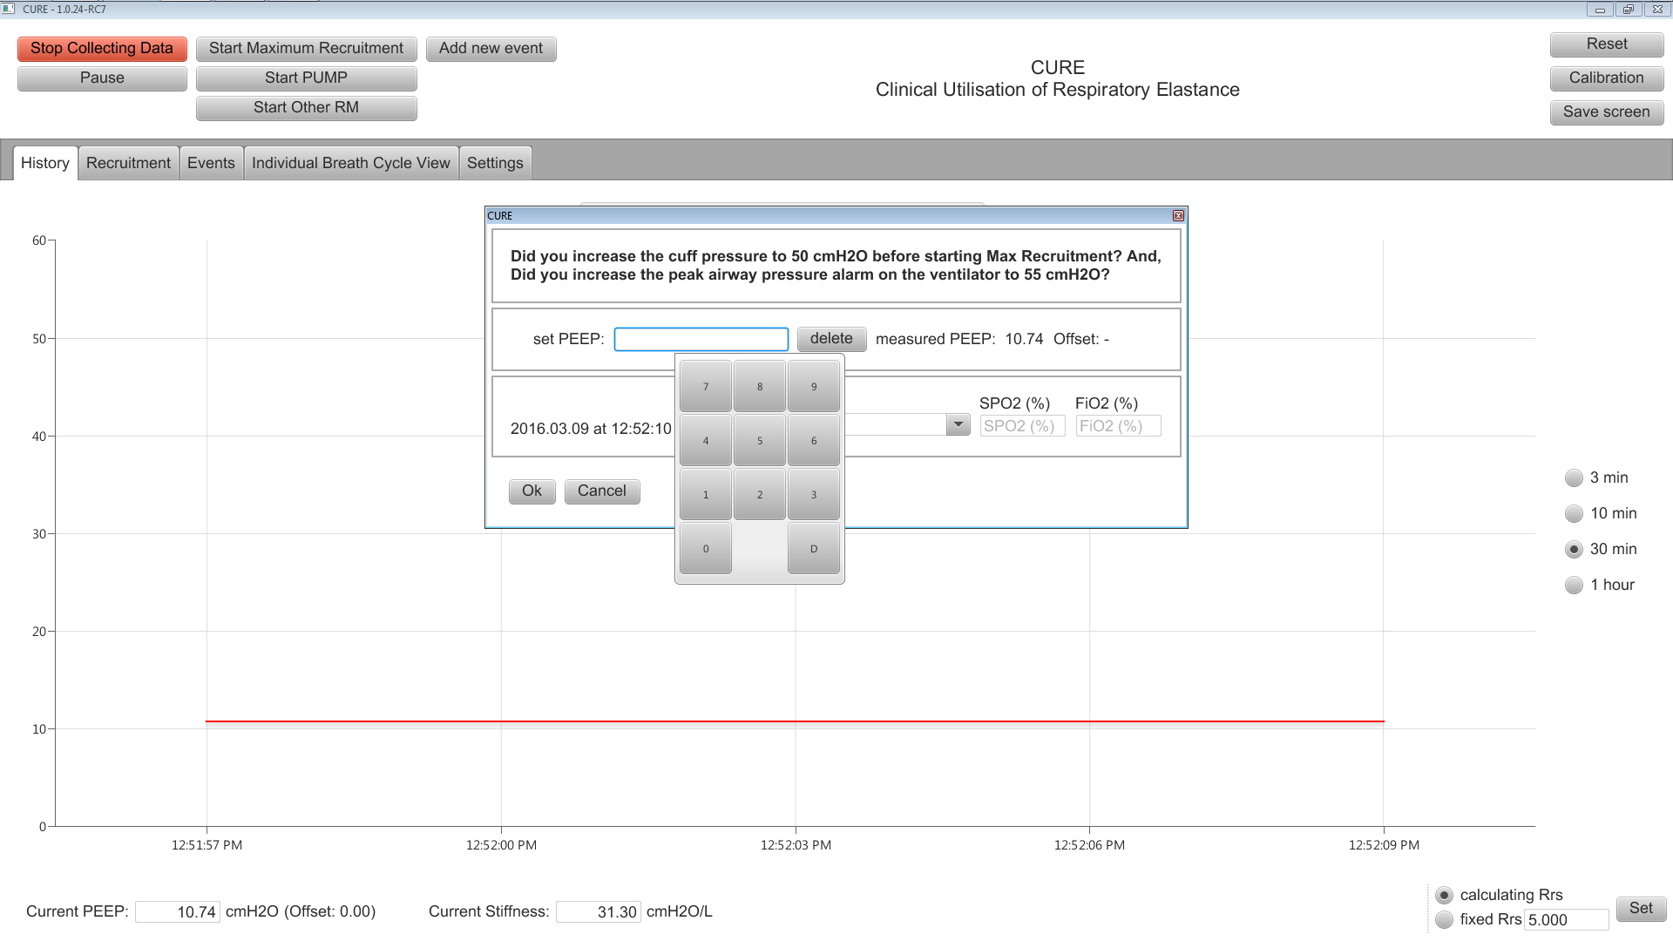

Step 3:

Wait for the green bar which says “PEEP seems to be stable. You can now set a new PEEP!” to appear, then a **blue** dot will appear. This dot shows the stiffness and PEEP level and appears each time the program records a stable PEEP.

Then Follow the PEEP guidance window on the bottom left corner of the window and change the PEEP to next suggested PEEP. ***The PEEP guide will increase PEEP until peak airway pressure (PIP) reaches ≥ 50 cmH2O.***

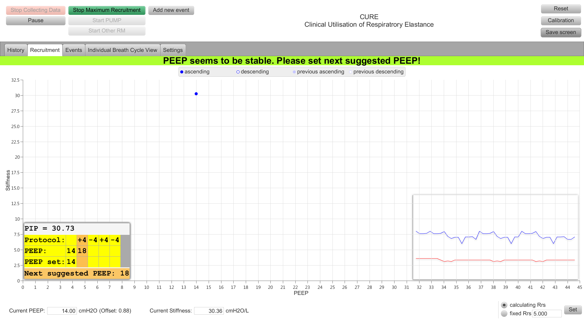

PEEP guidance window:

Increase PEEP to the “Next Suggested PEEP” setting

Dot has been plotted. This represents 14 cmH2O PEEP and an elastance (1/compliance) of 31 cmH2O/L

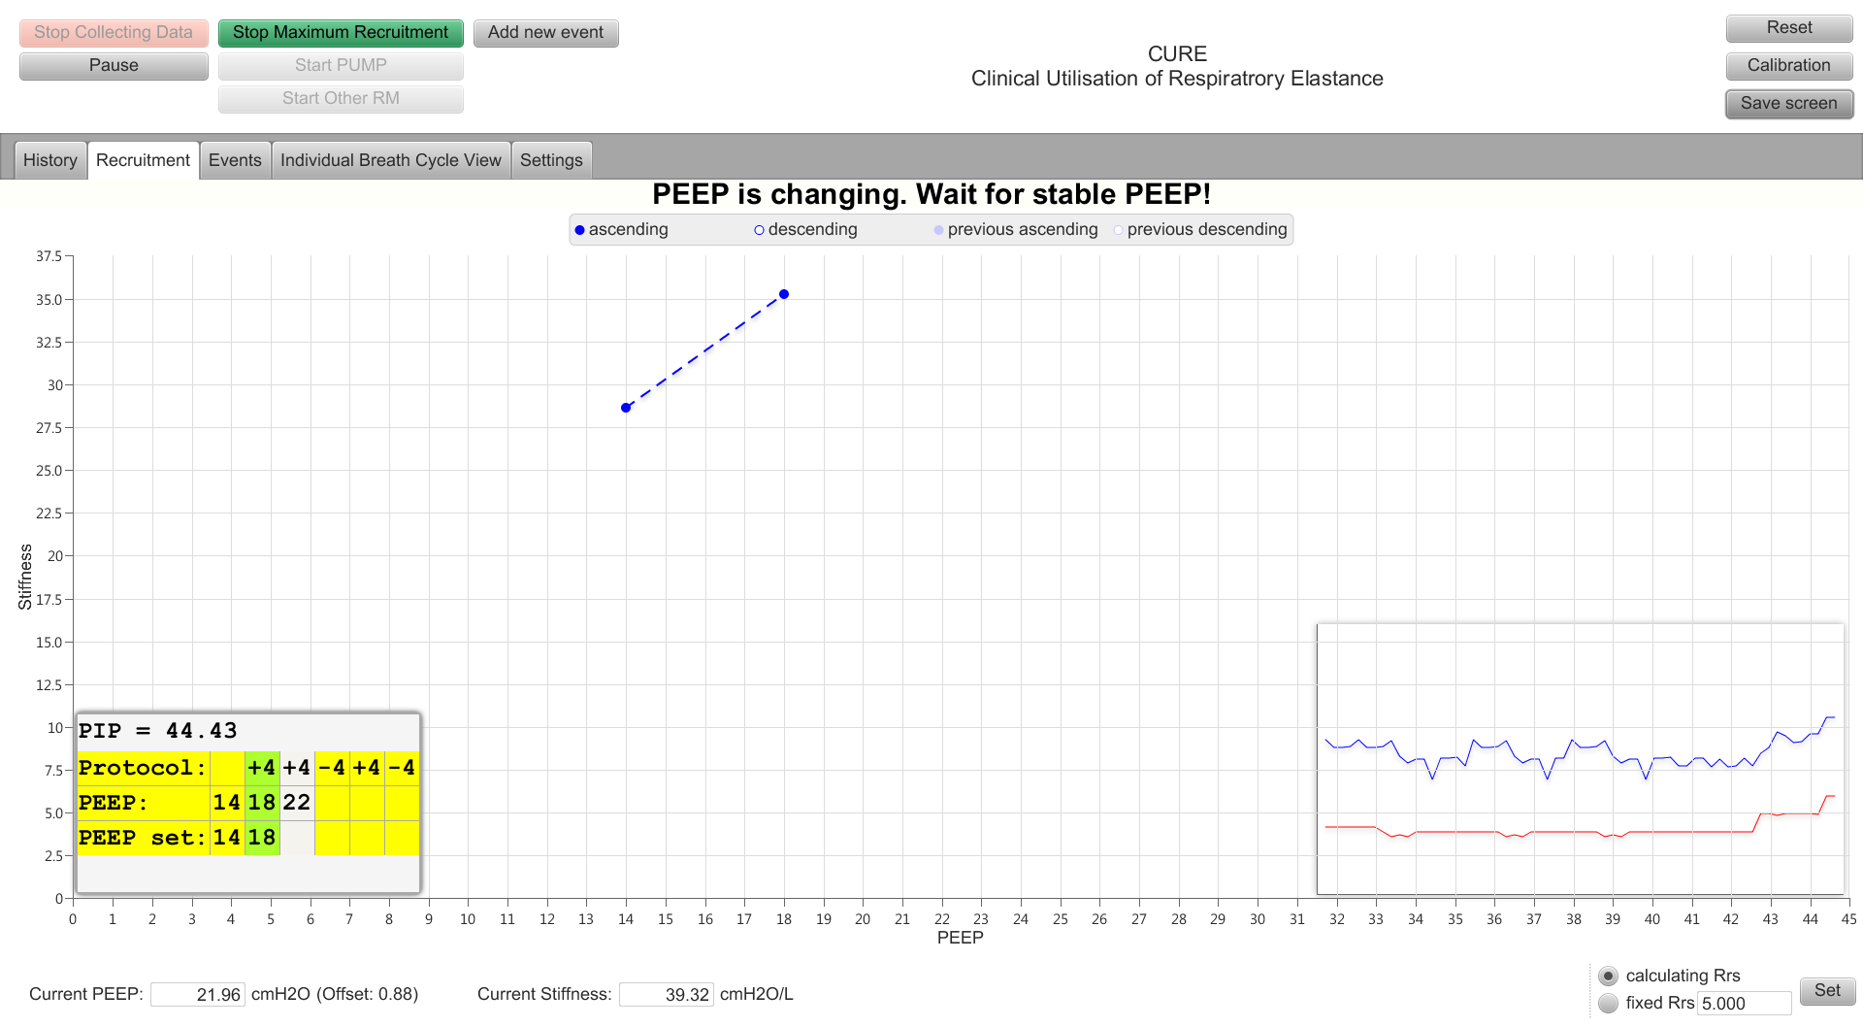

New dot appears when the program successfully records a stable PEEP of 18 cmH2O

Next Suggested PEEP is 22 cmH2O

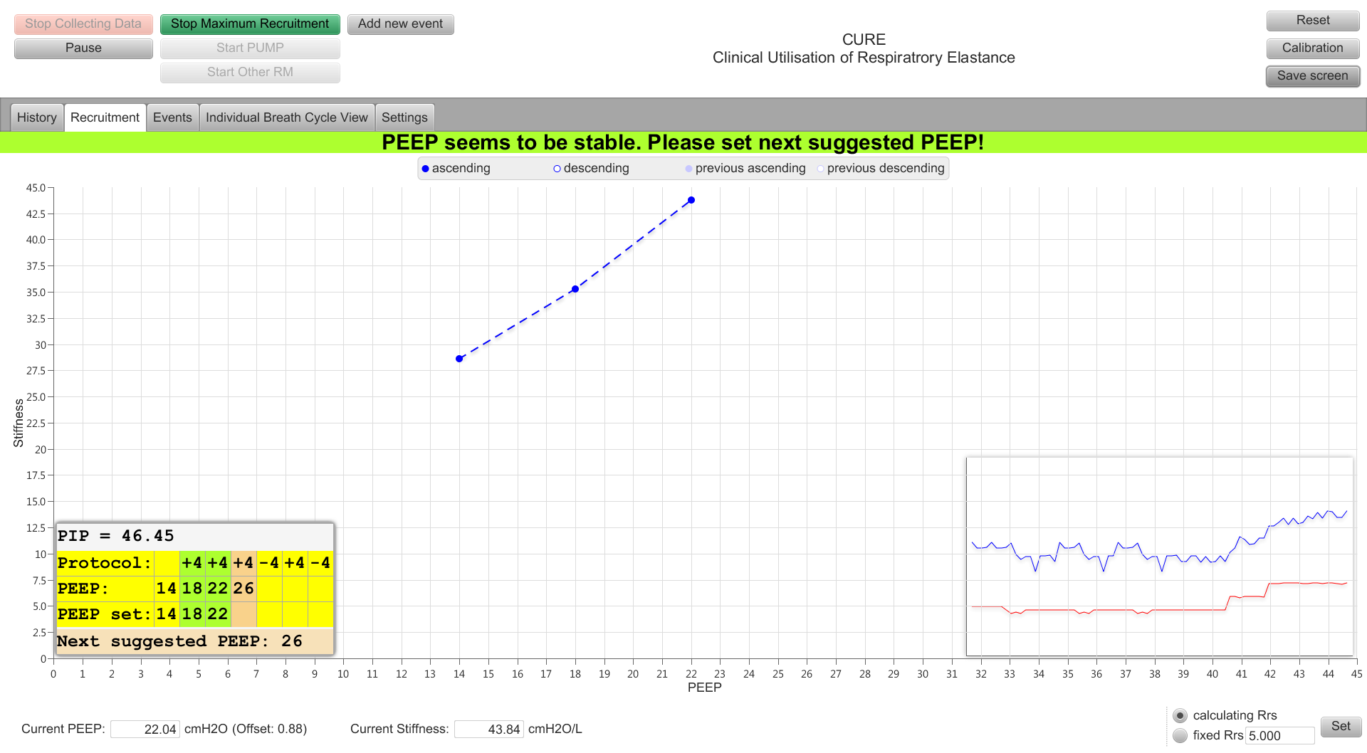

New dot appears when the program successfully records a stable PEEP of 22 cmH2O

Step 4: When PIP is ≥ 48cmH2O, PEEP is reduced by ***4 cmH2O*** steps until initial PEEP setting.

G:\screenshots\New folder\Incidence_2015.07.30-2.55.23.727.pngG:\screenshots\New folder\Incidence_2015.07.30-2.55.23.727.pngG:\screenshots\New folder\Incidence_2015.07.30-2.55.23.727.png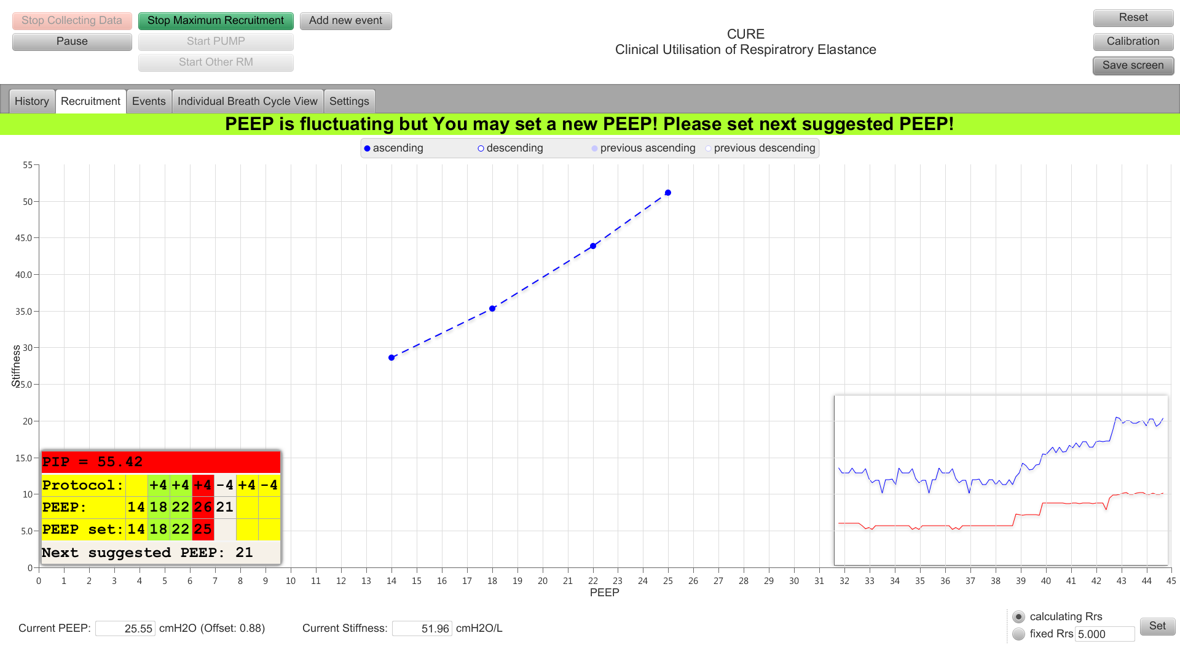

PIP *≥ 48* cmH2Otherefore reduce PEEP.

G:\screenshots\New folder\Incidence_2015.07.30-2.55.23.727.pngG:\screenshots\New folder\Incidence_2015.07.30-2.55.23.727.png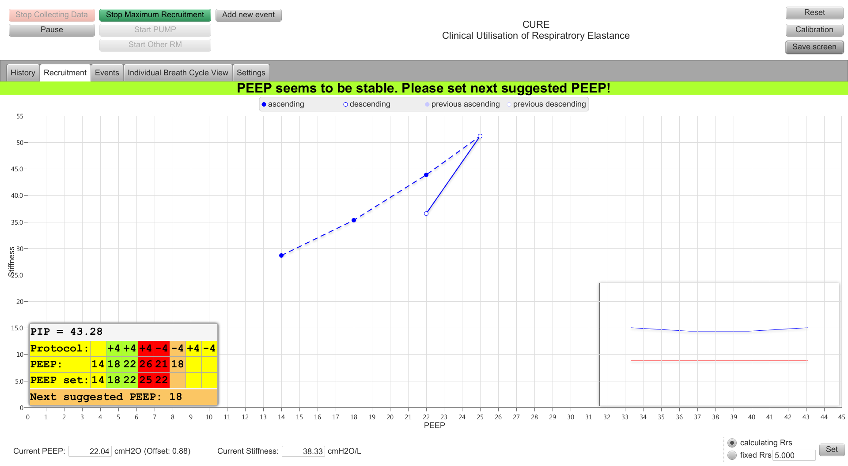

When PEEP is recorded continue to reduce PEEP another 4cmH2O (to 18 cmH2O)

PEEP is being reduced.

G:\screenshots\New folder\Incidence_2015.07.30-2.55.23.727.pngG:\screenshots\New folder\Incidence_2015.07.30-2.55.23.727.png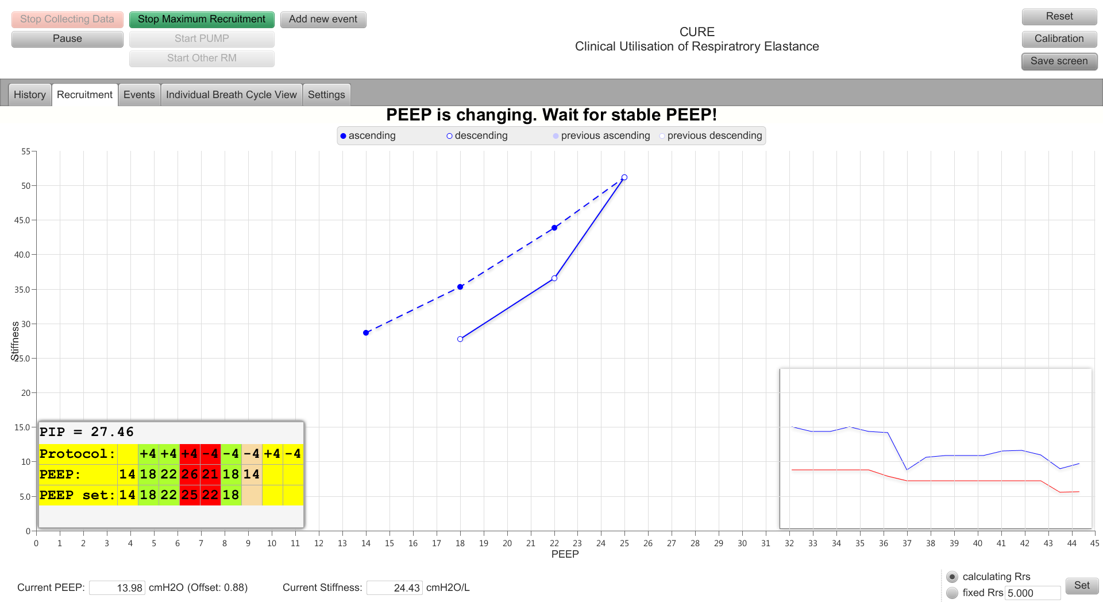

Continue to reduce PEEP by 4 cmH2O

Note the hysteresis due to lung recruitment

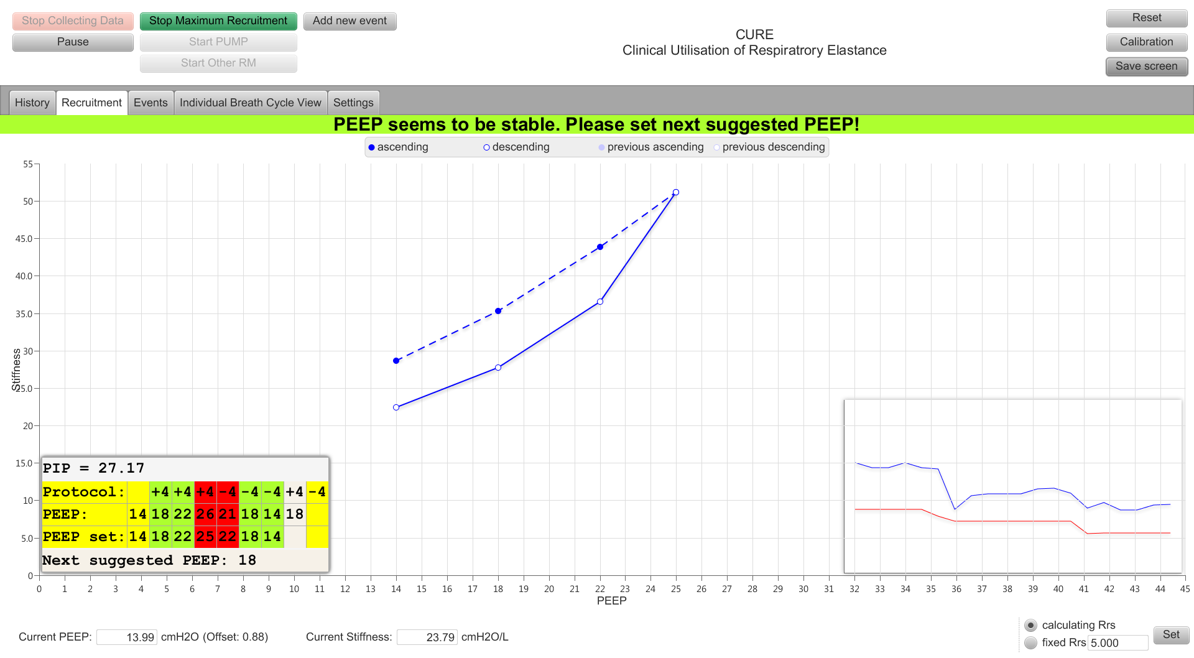

PEEP is back to initial PEEP.

(In this case 14 cmH20)

Step 5: When the PEEP is set back to the initial PEEP the banner will state “First RM has been finished. You can start the second RM! Please set Next suggested PEEP!”. Therefore iimmediately repeat the recruitment manoeuvre.

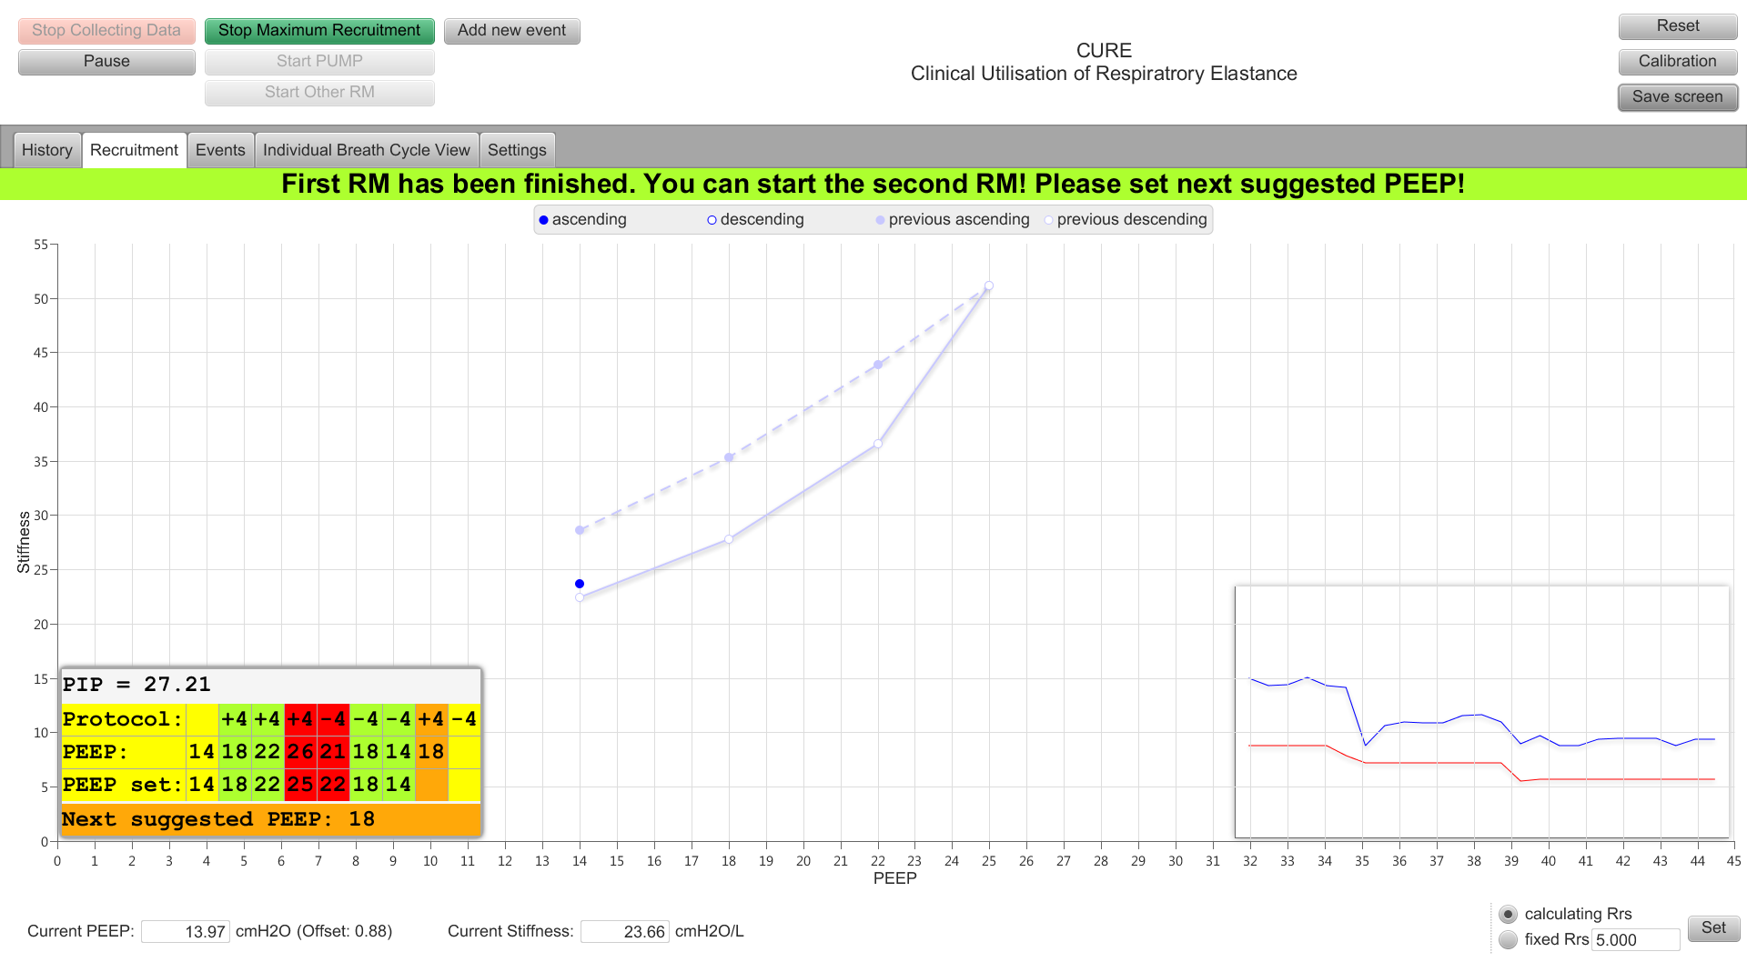

The first recruitment manoeuvre is faded to avoid confusion.

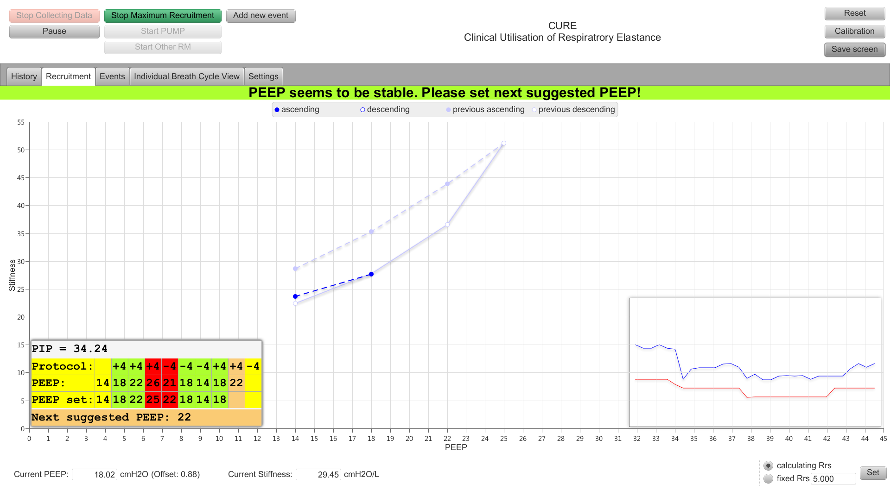

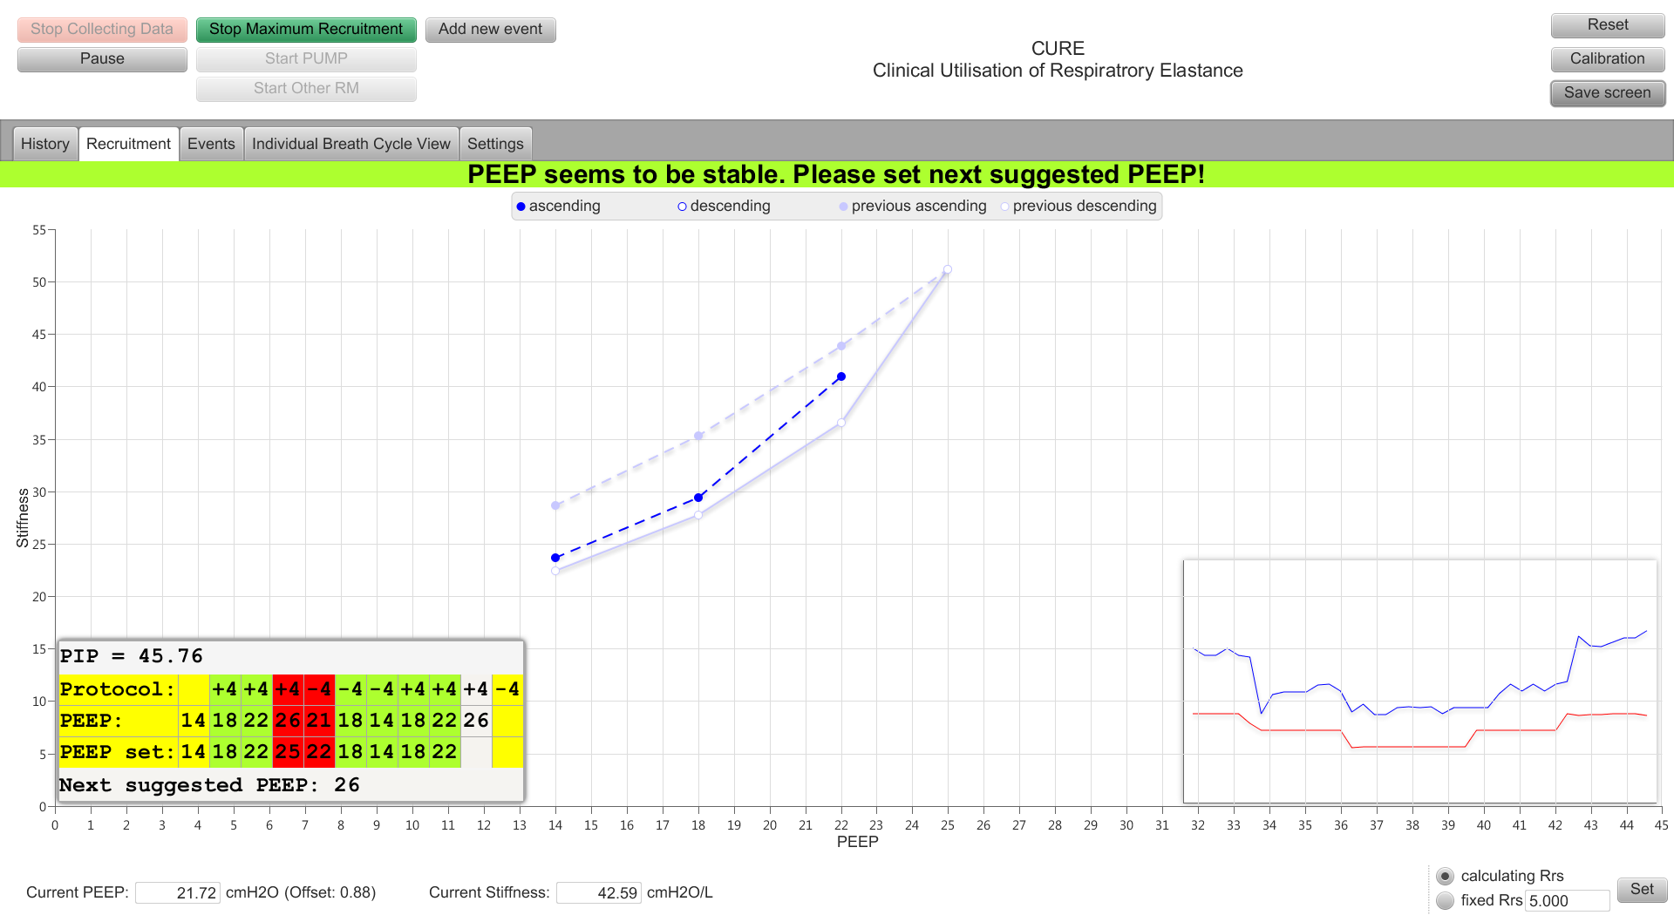

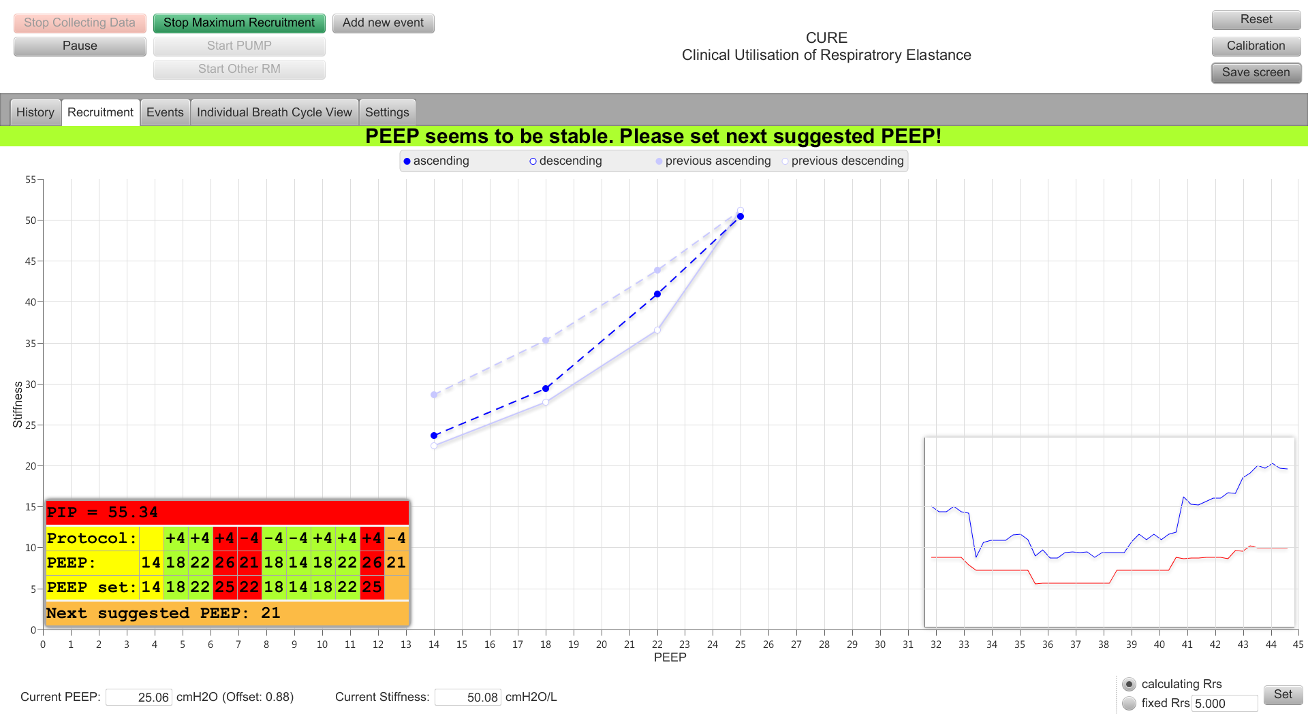

PIP is now above 48 cmH2O

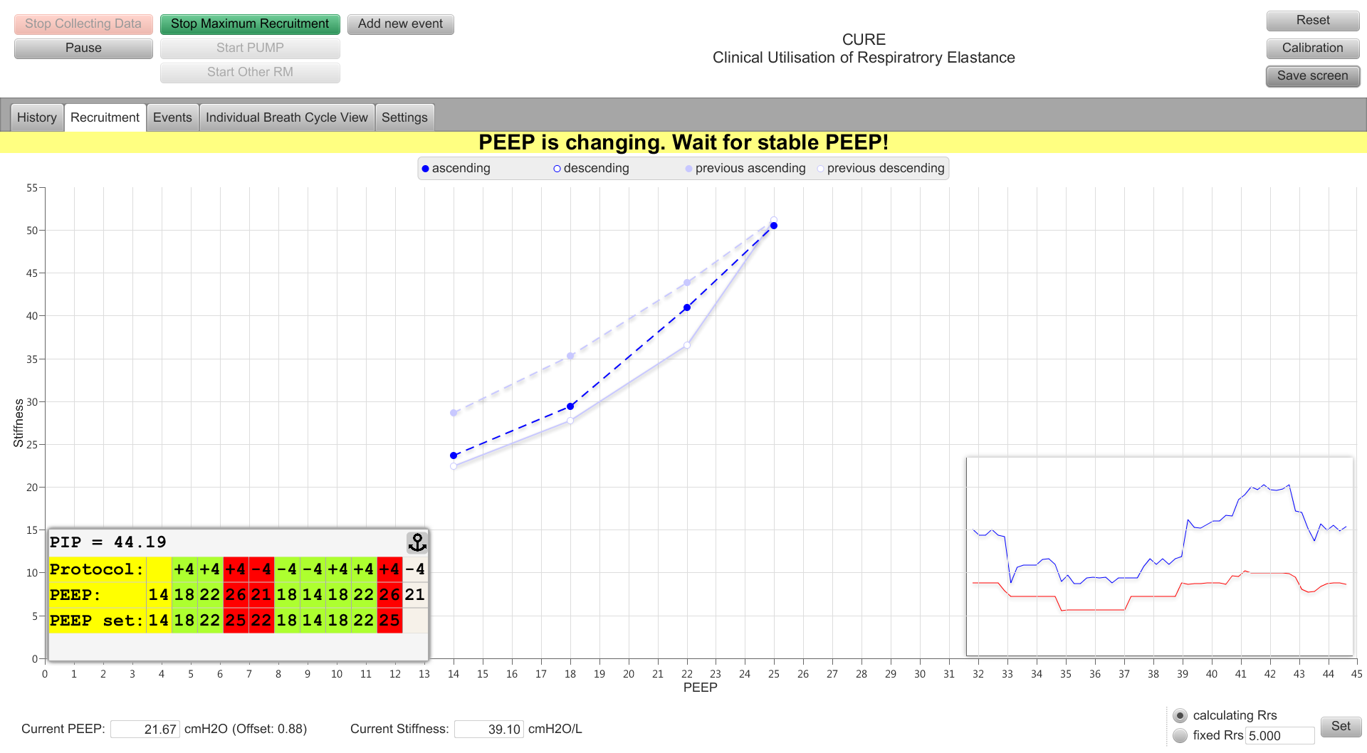

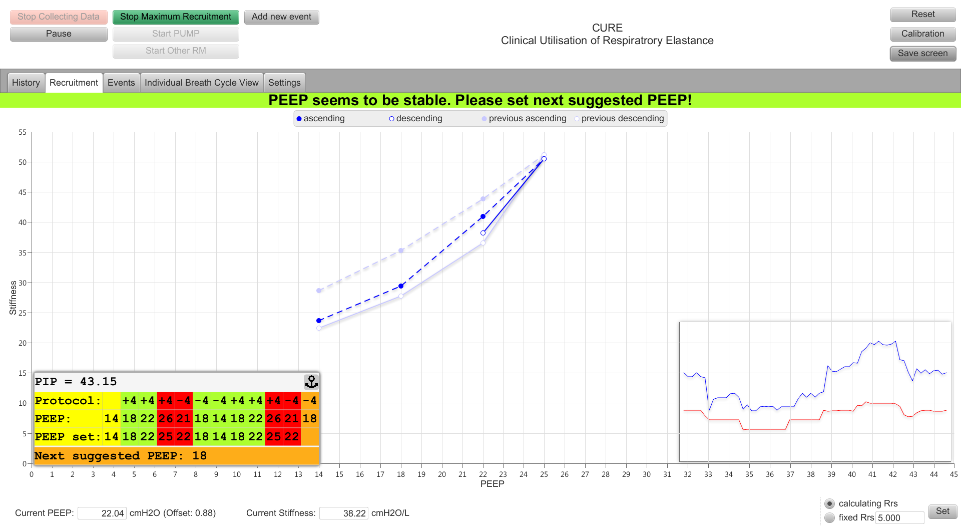

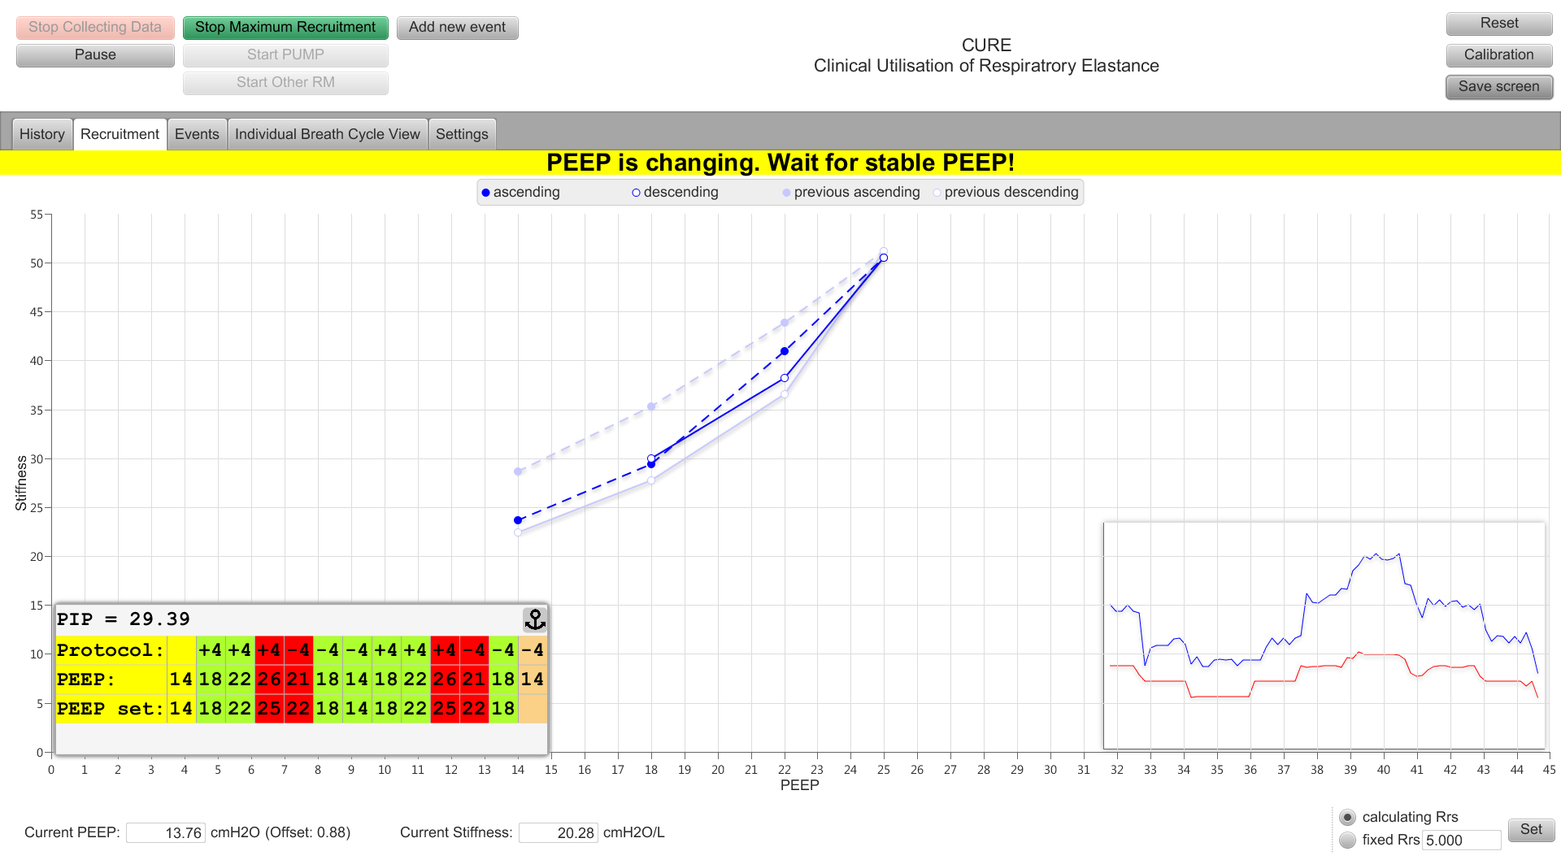

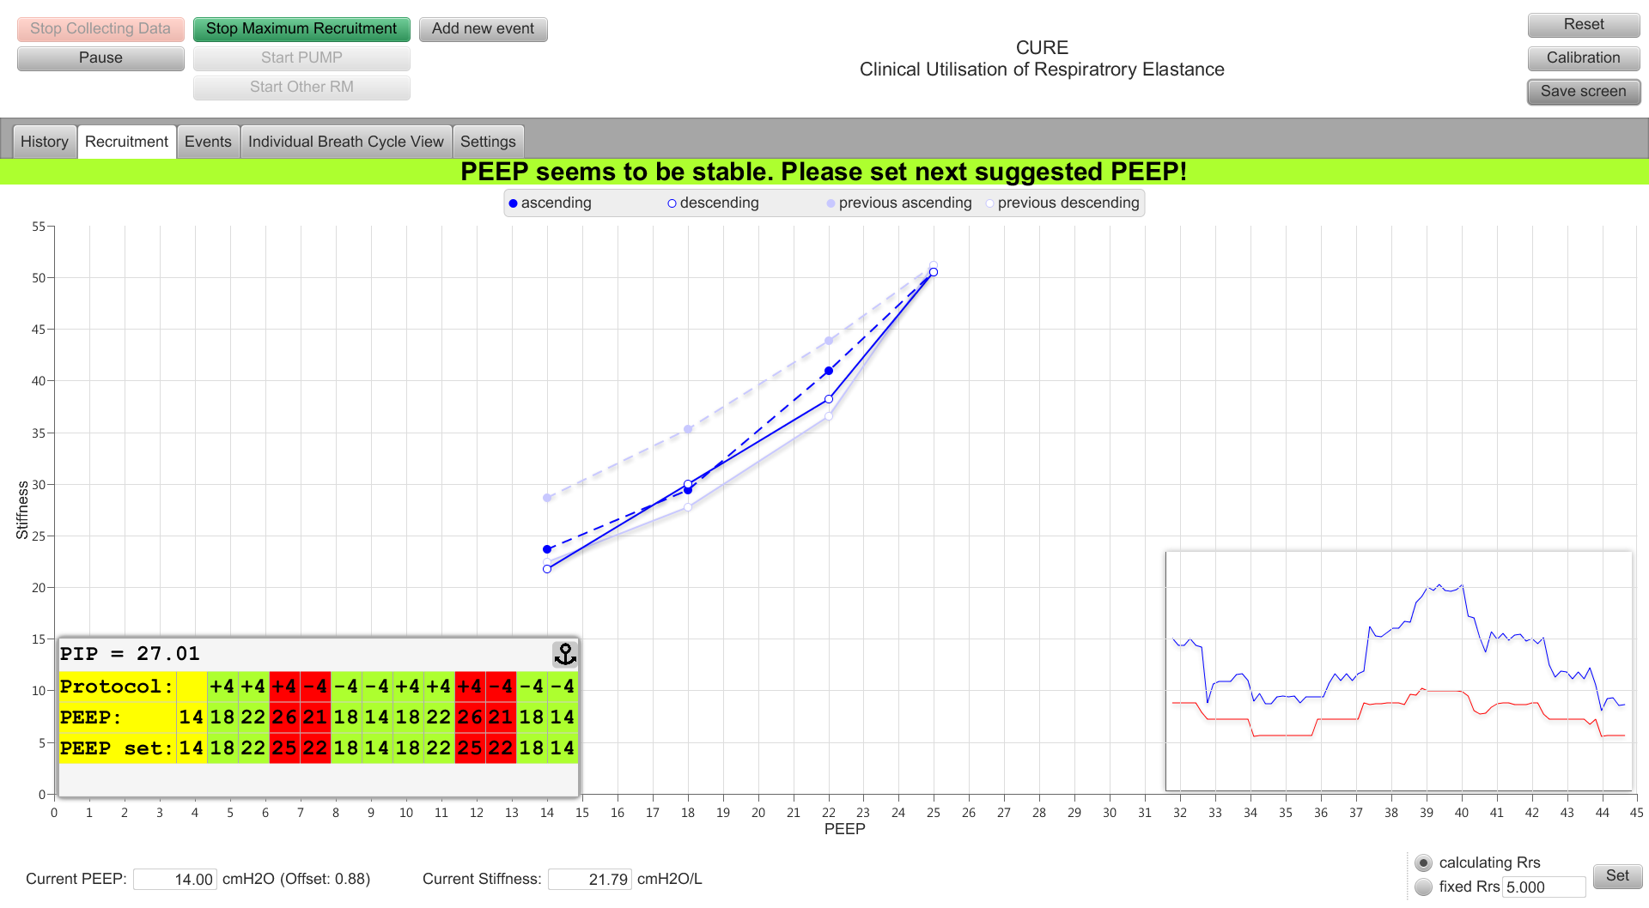

Note: The inflation and deflation loops are now very similar. This shows the initial recruitment has been maintained and no further recruitment has occurred following the second recruitment manoeuvre

1. When the second manoeuvre is finished, a window will show up asking

Either:

* + “***Accept***” the suggested PEEP and manually change the PEEP on the ventilator to this PEEP **or**
  + “***Reject***” the suggested PEEP. If you reject the suggested PEEP please record your reasons.

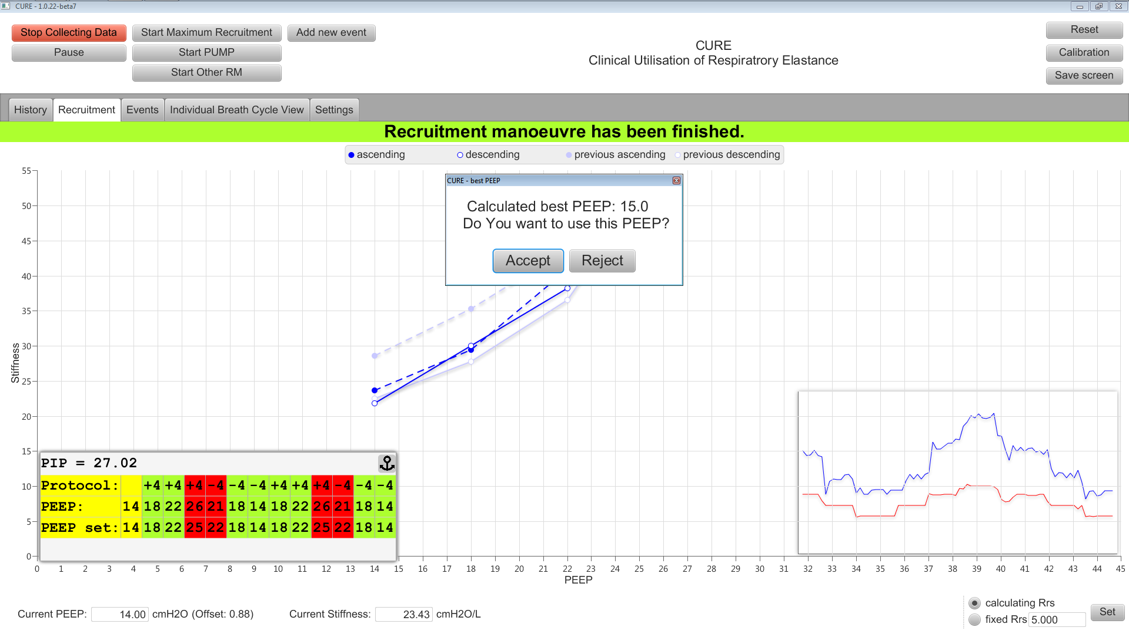

When PEEP is dropped back down to initial PEEP value, the RM is finished and CURESOFT will give optimal PEEP value. (15 cmH2O)

After Maximum Recruitment Manoeuvre:

* + **Return the cuff pressure back to ~30 cmH2O**
  + **Set ventilator alarms back to initial settings.**

**FOR Intervention (Model Based Ventilation) RANDOMISED PATIENTS ONLY**

**The** **PEEP Adjustment and Monitoring Procedure (PUMP). Carry this out:**

* When the patient is turned to supine position **or**
* Every 6 hours after the first RM, **or**
* If the FiO2 is increased by ≥10% **or**
* Any time at the clinician’s discretion **or**,

1. Click “***Start PUMP***”. Then It will ask you to calibrate PEEP

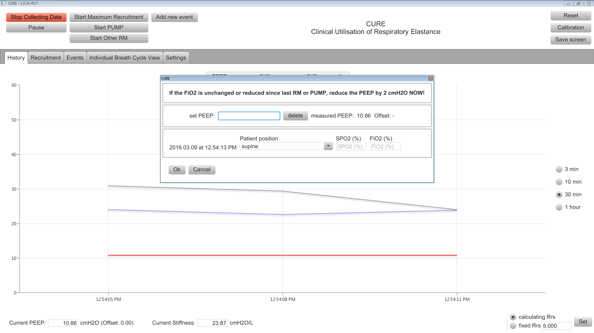

1. If the FiO2 is unchanged or reduced since last RM or PUMP, decrease the PEEP by 2 cmH2O on the ventilator and if the FiO2 is changed then do not decrease the PEEP.
2. Now enter in the ventilator set PEEP, SPO2 and FiO2. (NOTE: check that measured PEEP reads ventilator PEEP. If not then either wait few seconds for the PEEP level to stabilize or re-enter the PEEP that is set on the ventilator)

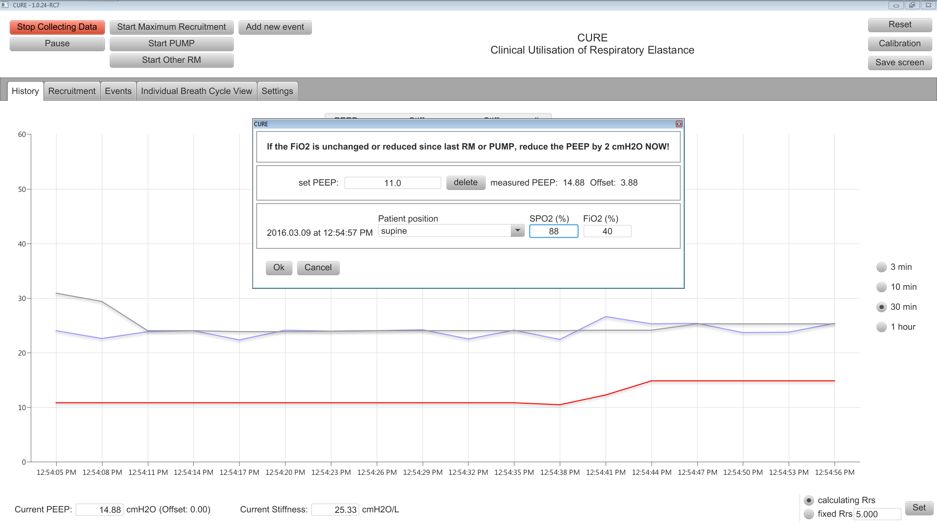

Enter in patient position, SpO2 and FiO2 in the appropriate fields

e.g. position = ***“supine”*** *SpO2* = **“90%”** and *FiO2* = “**50%”**

1. Increase PEEP in two steps of ***4 cmH2O*** (waiting for stable PEEP before changing PEEP) before decreasing back two steps of ***4 cmH2O*** to the starting PEEP level. (The starting PEEP level is *either 2 cm H2O below baseline* if the FiO2 is constant or falling, or *at the baseline* PEEP setting if the FiO2 has increased)

**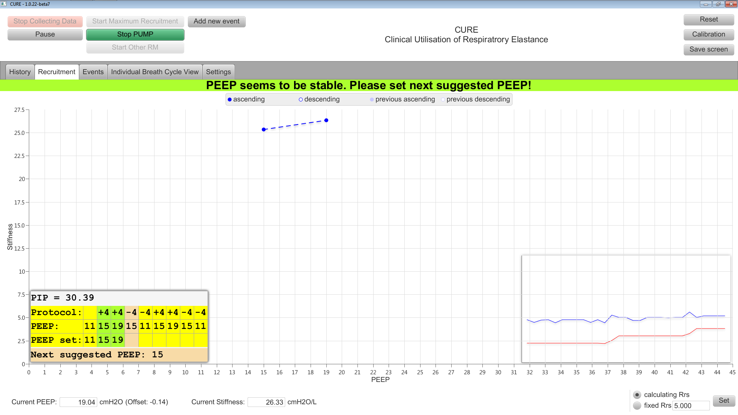**

1. Immediately **repeat** this manoeuvre.

**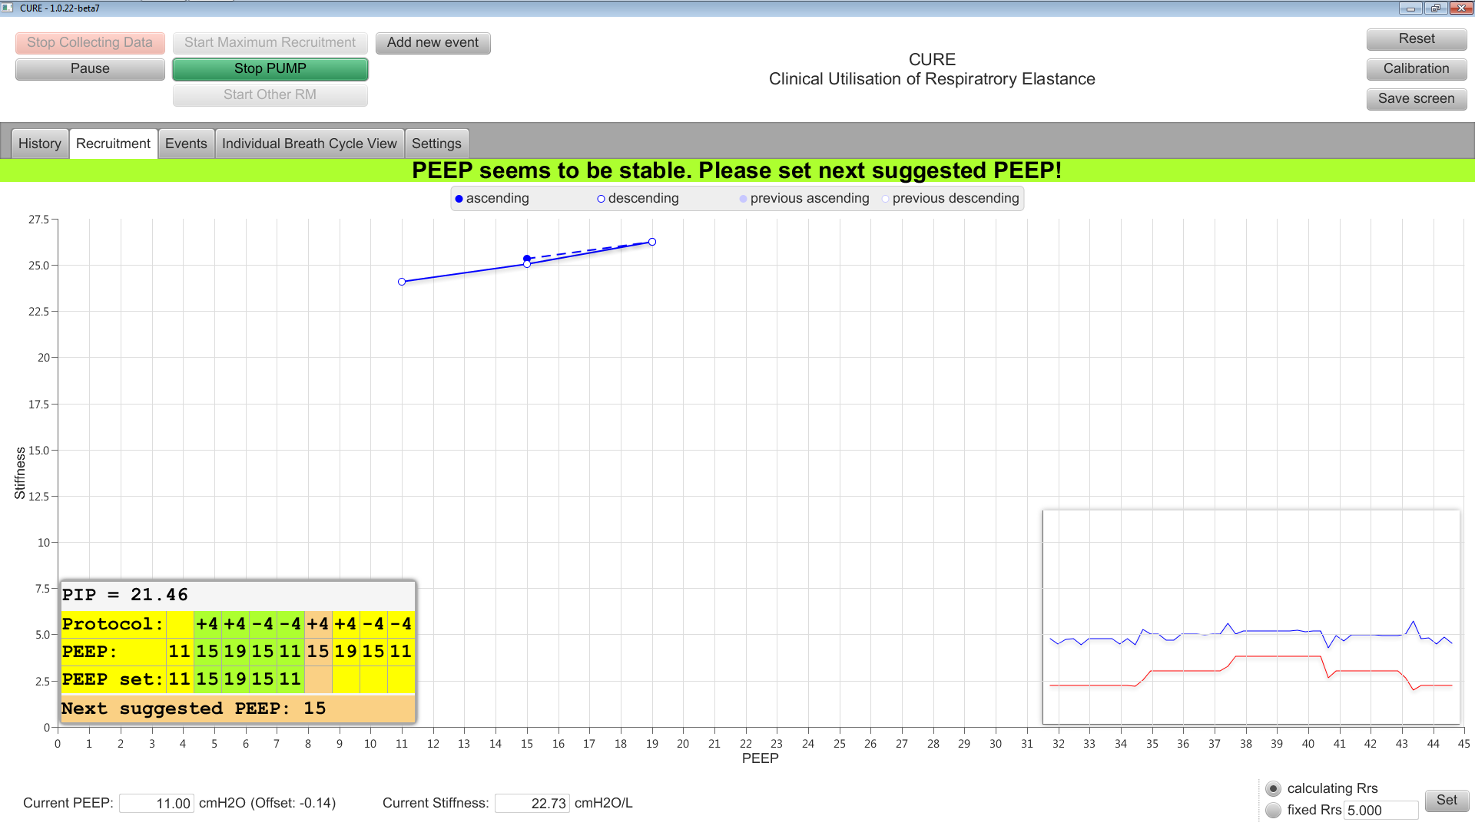**

1. Push “***Stop Recruitment Manoeuvre***” button, and an optimal PEEP will be recommended.

Either:

* + “***Accept***” the suggested PEEP and manually change the PEEP on the ventilator to this PEEP **or**
  + “***Reject***” the suggested PEEP. If reject, a prompt to record the reasons for rejection will come up.

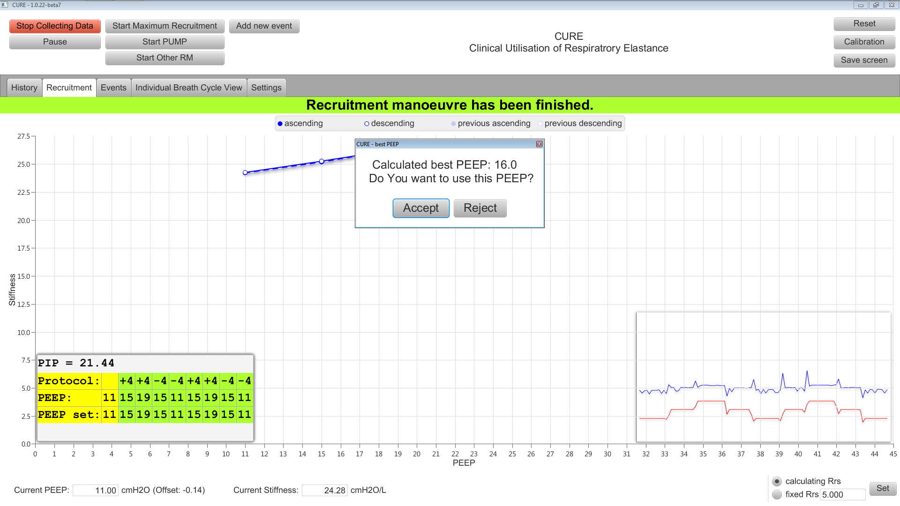

**FOR Intervention (Model Based Ventilation) RANDOMISED PATIENTS ONLY**

**Add new event**. Do this procedure:

* When the patient is turned, **or**
* Every time the patient’s airway is suctioned, **or**
* Any time patient is disconnected from ventilator **or**
* Any other important details that is worth mentioning

1. Click on the “**Add new event**” button.
2. Either click on the predefined event buttons or type in an event followed by SPO2 and FiO2 or click add.

